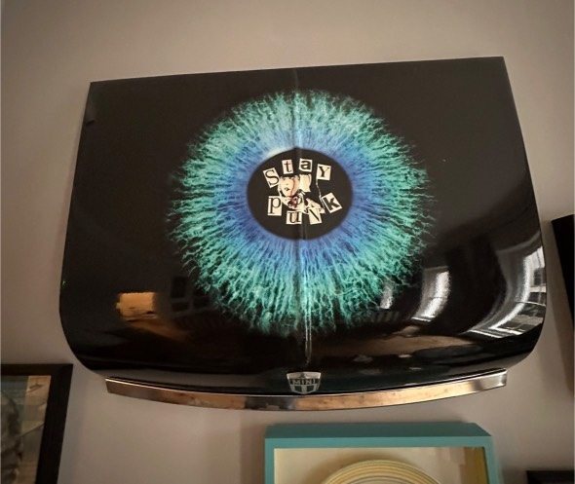
ARTIST: MARK WOOLLEY
TITLE: STAY PUNK
SIZE: MINI BONNET SIZE
MEDIUM: MIXED MEDIA ON MINI BONNET
PRICE: £1,950.00

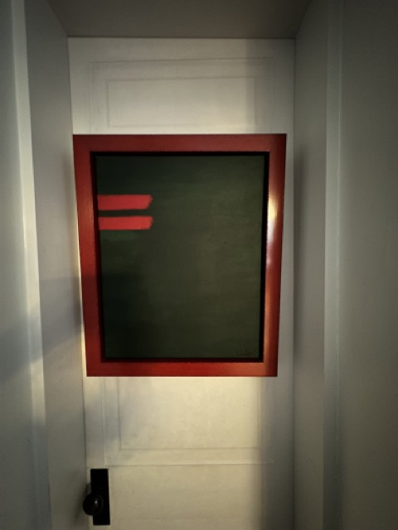
ARTIST: MARK WOOLLEY
TITLE: IN THE FIELDS
SIZE: 40 x 30 cm Approx. ( Red Tray Frame )
MEDIUM: ACRYLIC ON CANVAS
PRICE: £ 750.00
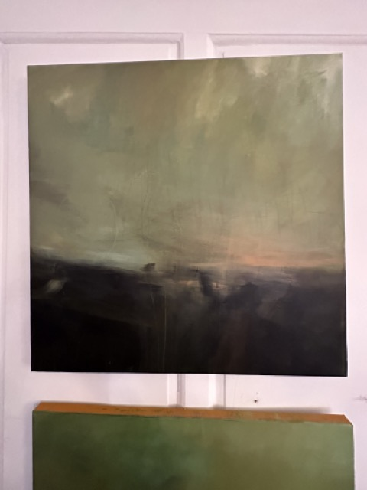

ARTIST: DAVID BRAY
TITLE: MORE COWBELL
SIZE: 1 mtr x 1 mtr
MEDIUM: Acrylic on Canvas
PRICE: £ 3,400

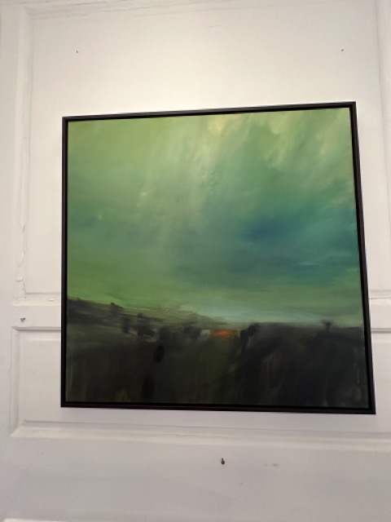
ARTIST: DAVID BRAY
TITLE: A CHANGE OF HORSES
SIZE: 100 CM x 100 CM
MEDIUM: Acrylic on Canvas (tray Framed)
PRICE: £ 3,550
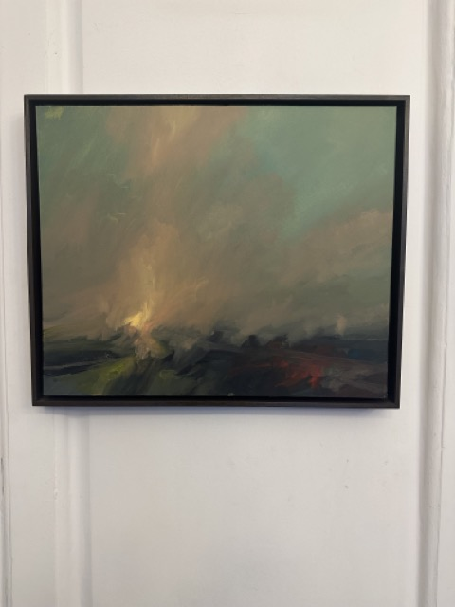
ARTIST: DAVID BRAY
TITLE: FELL INTO THE SUN
SIZE: 60 X 50 CM
MEDIUM: ACRYLIC ON CANVAS (tray framed)
PRICE: £ 1,750.00

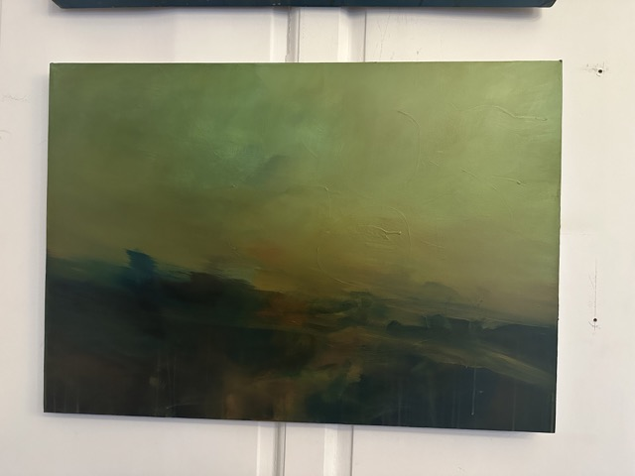
ARTIST: DAVID BRAY
TITLE: GO TELL IT TO THE TREES
SIZE: 100 X 70 CM
MEDIUM: ACRYLIC ON CANVAS
PRICE: £ 2,350.00
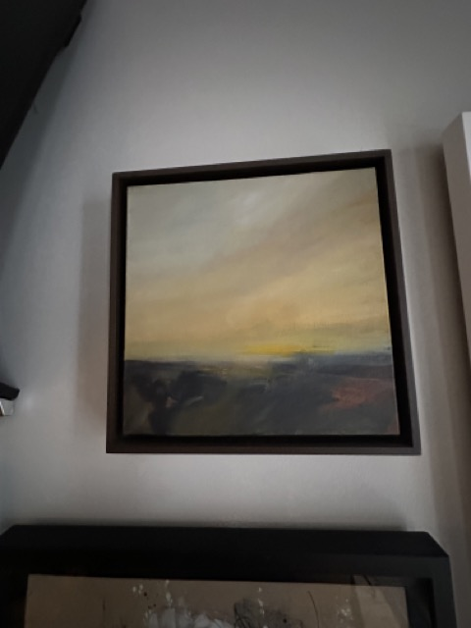
ARTIST: DAVID BRAY
TITLE: CUSTARD FRITTERS
SIZE: 34 X 34 CM
MEDIUM: ACRYLIC ON CANVAS (tray framed)
PRICE: £ 875.00

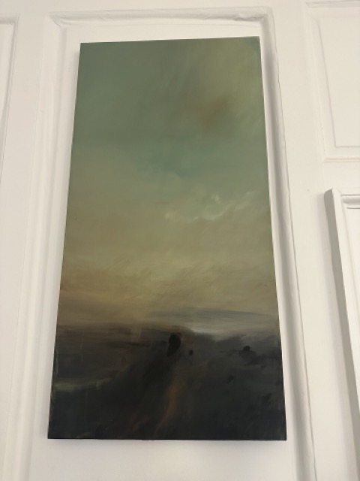
ARTIST: DAVID BRAY
TITLE: THIRD TREE ON THE LEFT
SIZE: 100 X 50 CM
MEDIUM: ACRYLIC ON CANVAS
PRICE: £ 1,750.00
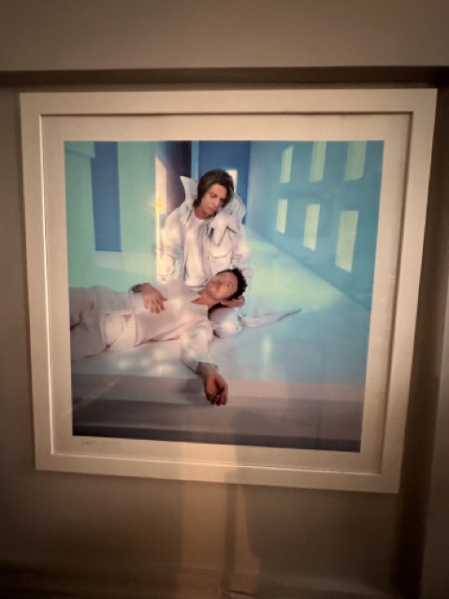
ARTIST: TIM BRETDAY
TITLE: BOWIE
SIZE: 80 x 80 CM approx. (framed)
MEDIUM: GICLEE PHOTOGRAPHIC PRINT (FRAMED)
PRICE: £900.00

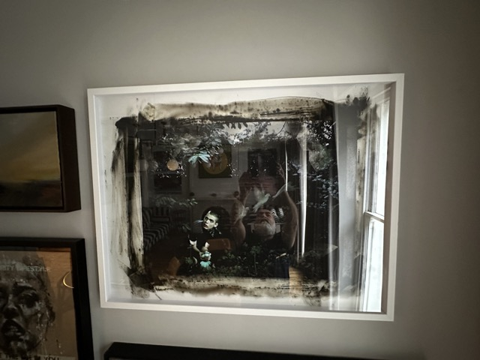
ARTIST: TIM BRETDAY
TITLE: DOVES
SIZE: 100 x 70 CM. ( Framed )
MEDIUM: GICLEE PHOTOGRAPHIC PRINT (FRAMED)
PRICE: £ 900.00
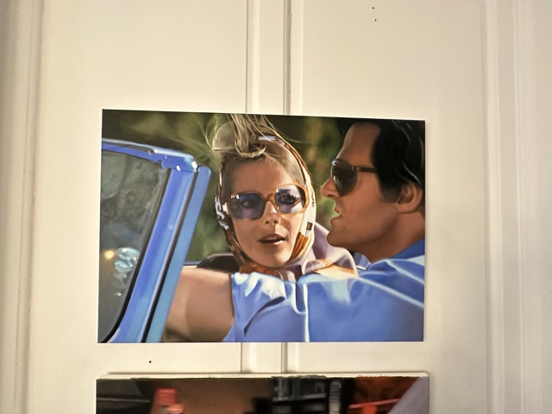
ARTIST: BEN ADDISON
TITLE: BOB & CAROL
SIZE: 100 X 90 CM
MEDIUM: OIL ON CANVAS
PRICE: £ 5,000.00

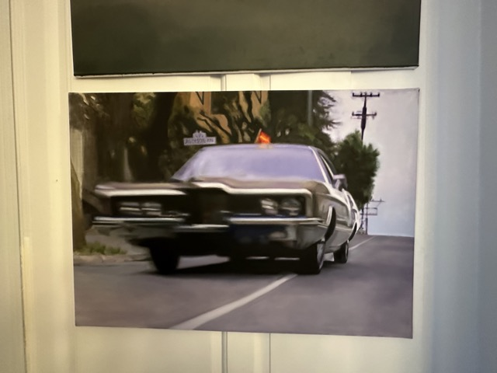
ARTIST: BEN ADDISON
TITLE: ADDISON AVENUE
SIZE: 100 X 90 CM
MEDIUM: OIL ON CANVAS
PRICE: £ 5,000.00

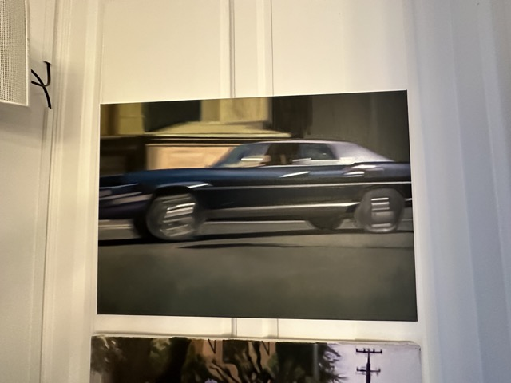
ARTIST: BEN ADDISON
TITLE: SEQUENTIAL MOTORDRIVE
SIZE: 100 X 90 CM
MEDIUM: OIL ON CANVAS
PRICE: £ 5,000.00

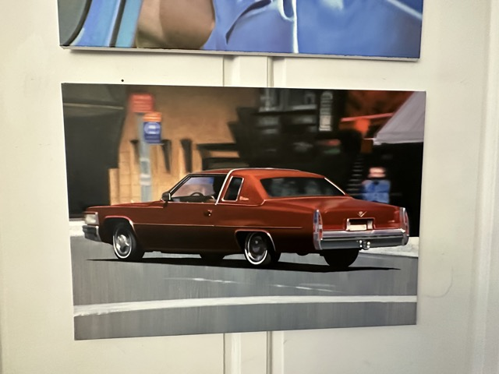
ARTIST: BEN ADDISON
TITLE: FORGEDDABOUTIT
SIZE: 100 X 90 CM
MEDIUM: OIL ON CANVAS
PRICE: £ 5,000.00
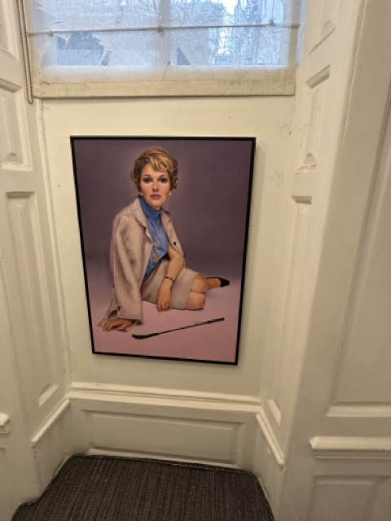
ARTIST: BEN ADDISON
TITLE: THE SECRET TO SOFTER SKIN
SIZE: 62 X 90 CM
MEDIUM: OIL ON BOARD ( TRAY FRAMED )
PRICE: £ 4,000.00

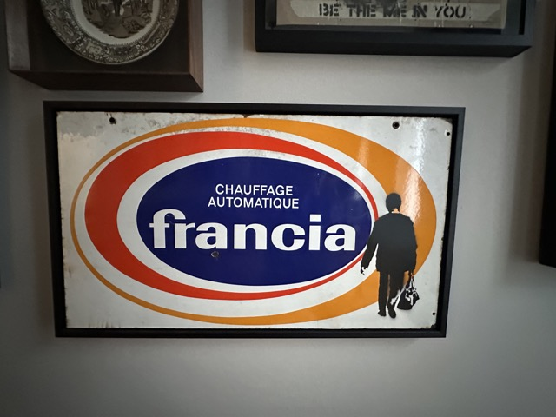
ARTIST: BEN OAKLEY
TITLE: HEAT UP & AWAY
SIZE: 77 X 43 CM
MEDIUM: SPRAY PAINT ON VINTAGE ENAMEL ( TRAY FRAMED )
PRICE: £ 575.00

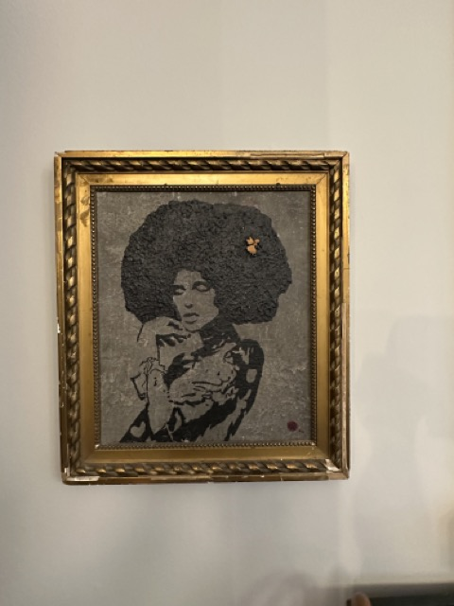
ARTIST: BEN OAKLEY
TITLE: CONCRETE SOUL
SIZE: 40 x 30 CM approx. ( ANTIQUE GILT FRAME )
MEDIUM: ACRYLIC /MIXED MEDIA
PRICE: £ 950.00

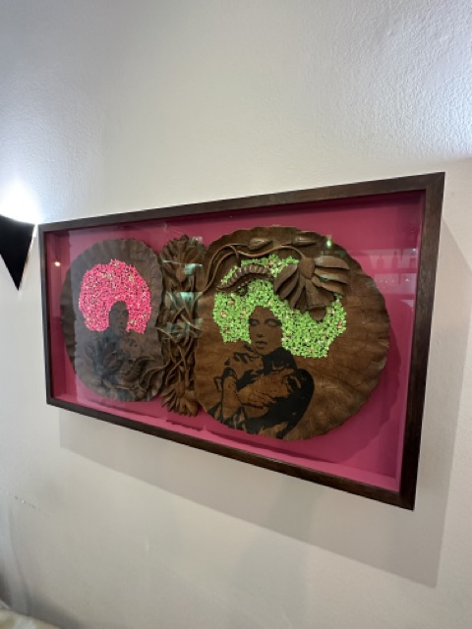
ARTIST: BEN OAKLEY
TITLE: DOUBLE SOUL SISTER
SIZE: 90 x 50 CM approx. Deep Box Frame
MEDIUM: MIXED MEDIA -POLYNESIAN HANDCARVED FRUIT PLATE
PRICE: £ 2,450.00

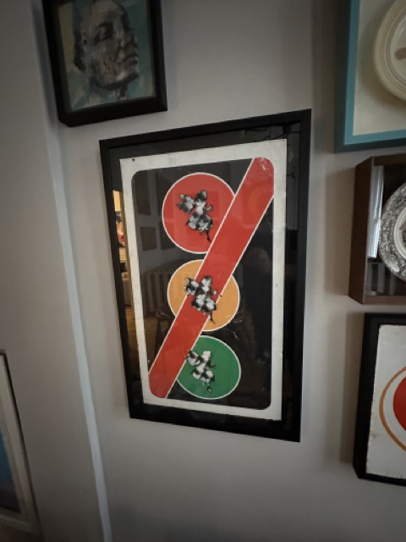
ARTIST: BEN OAKLEY
TITLE: FAIRY (TRAFFIC) LIGHTS
SIZE: 90 x 40 CM (Framed)
MEDIUM: SPRAY PAINT ON TRAFFIC SIGN
PRICE: £ 425.00

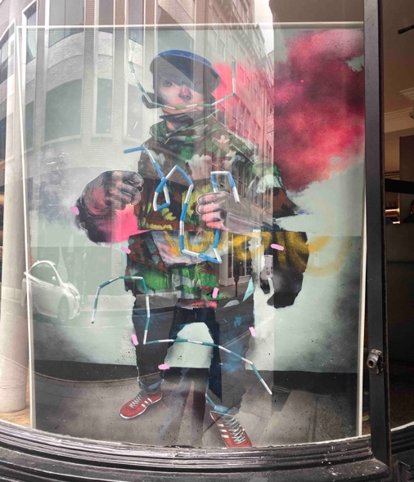
ARTIST: SWELER
TITLE: DOUBLE YELLOW
SIZE: 1.8 MTR X 1.2 MTR
MEDIUM: SPRAY PAINT & ACRYLIC ON CANVAS
PRICE: £15,000
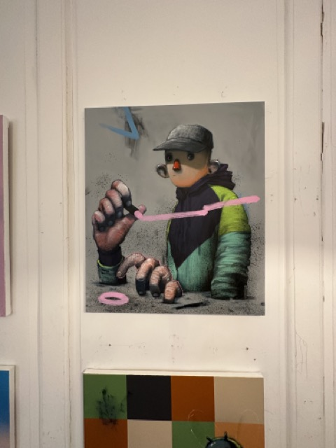
ARTIST: SWELER
TITLE: LINES & CIRCLES
SIZE: 60 X 70 CM
MEDIUM: SPRAY PAINT & ACRYLIC ON CANVAS
PRICE: £1,880.00

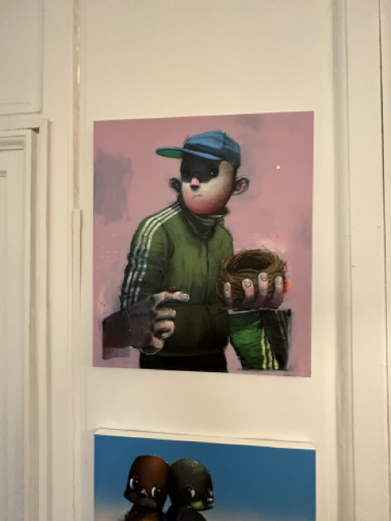
ARTIST: SWELER
TITLE: MERCURY RISING
SIZE: 60 X 70 CM
MEDIUM: SPRAY PAINT & ACRYLIC ON CANVAS
PRICE: £1,880.00
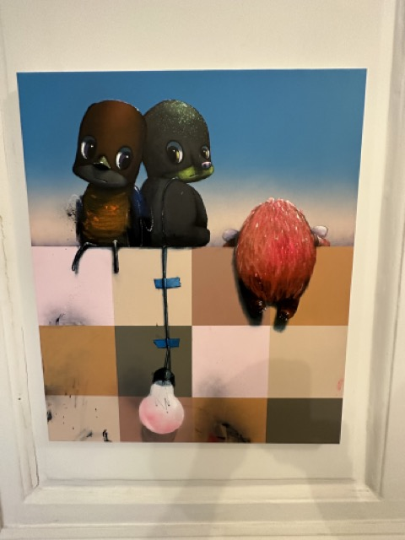
ARTIST: SWELER
TITLE: OVER THE WALL
SIZE: 60 X 70 CM
MEDIUM: SPRAY PAINT & ACRYLIC ON CANVAS
PRICE: £ 2,000

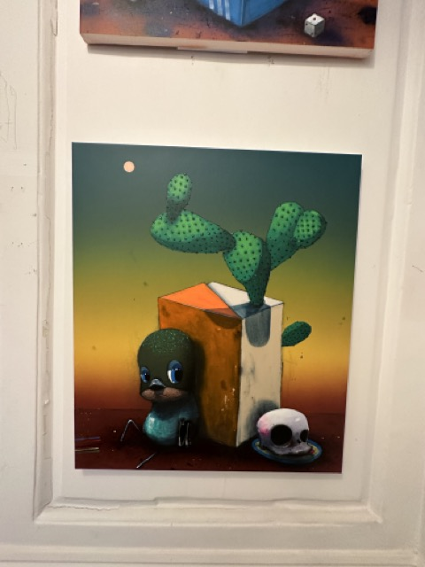
ARTIST: SWELER
TITLE: CACTUS BOX
SIZE: 60 X 70 CM
MEDIUM: SPRAY PAINT & ACRYLIC ON CANVAS
PRICE: £ 2,000

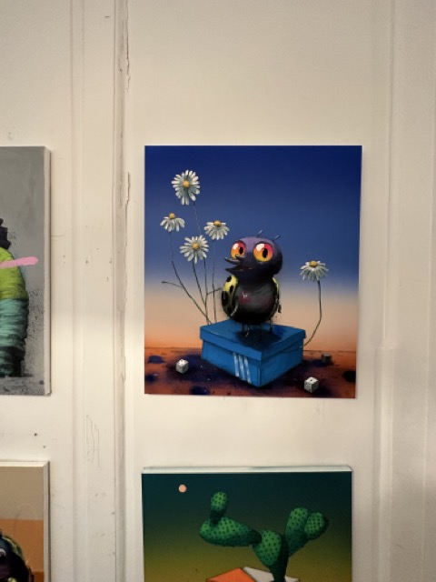
ARTIST: SWELER
TITLE: CHAMOMILE
SIZE: 60 X 70 CM
MEDIUM: SPRAY PAINT & ACRYLIC ON CANVAS
PRICE: £ 2,000

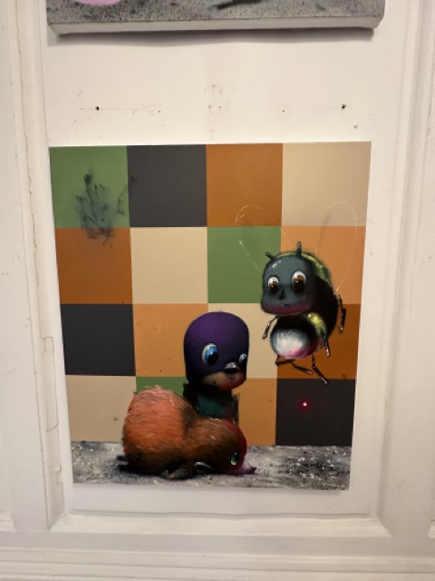
ARTIST: SWELER
TITLE: PROMISE OF FORTUNE
SIZE: 60 X 80 CM
MEDIUM: SPRAY PAINT & ACRYLIC ON CANVAS
PRICE: £ 2,000.

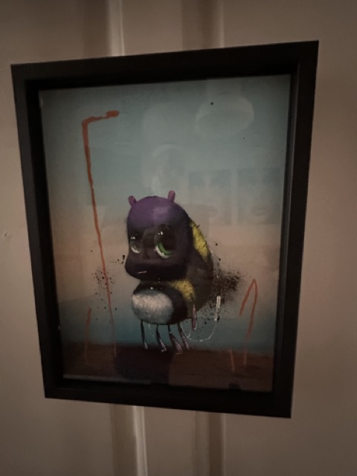
ARTIST: SWELER
TITLE: DESTINATION
SIZE: 36 X 46 CM
MEDIUM: 1/1 SPRAY & ACRYLIC ON CARD ( FRAMED )
PRICE: £ 675.00

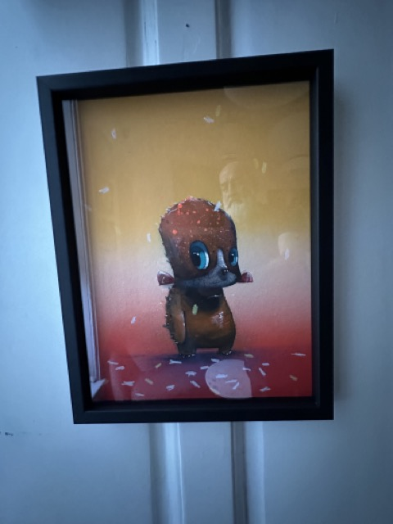
ARTIST: SWELER
TITLE: ENCORE
SIZE: 36 X 46 CM
MEDIUM: 1/1 SPRAY & ACRYLIC ON CARD ( FRAMED )
PRICE: £ 675.00
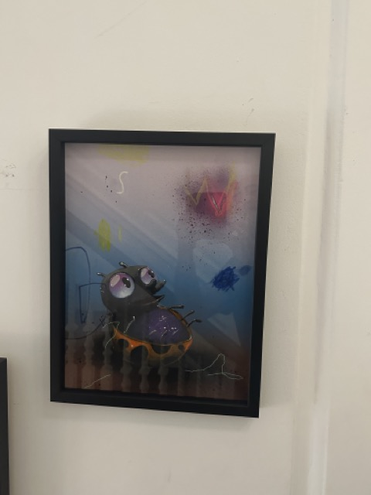
ARTIST: SWELER
TITLE: SHARE THE FALL
SIZE: 36 X 46 CM
MEDIUM: 1/1 SPRAY & ACRYLIC ON CARD ( FRAMED )
PRICE: £ 675.00

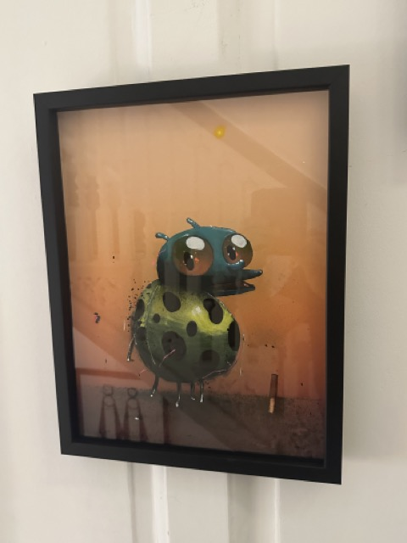
ARTIST: SWELER
TITLE: TRUST
SIZE: 36 X 46 CM
MEDIUM: 1/1 SPRAY & ACRYLIC ON CARD ( FRAMED )
PRICE: £ 675.00
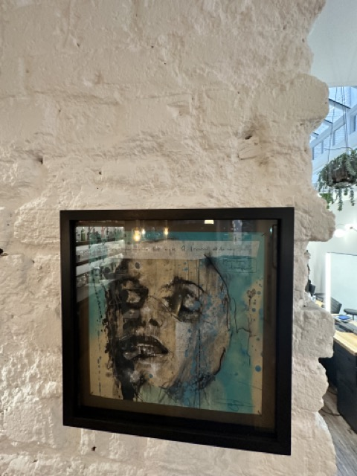
ARTIST: GUY DENNING
TITLE: VISAGE 1
SIZE: 29 X 29 CM ( FRAMED )
MEDIUM: MIXED MEDIA ON FINE ART PAPER
PRICE: £ 575.00

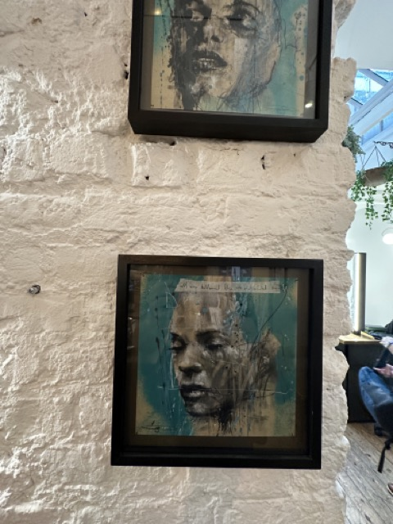
ARTIST: GUY DENNING
TITLE: VISAGE 2
SIZE: 29 X 29 CM. ( FRAMED )
MEDIUM: MIXED MEDIA ON FINE ART PAPER
PRICE: £ 575.00
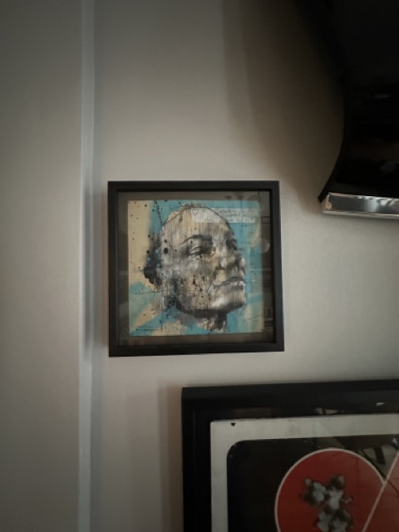
ARTIST: GUY DENNING
TITLE: VISAGE 3
SIZE: 29 X 29 CM. ( FRAMED )
MEDIUM: MIXED MEDIA ON FINE ART PAPER
PRICE: £ 575.00

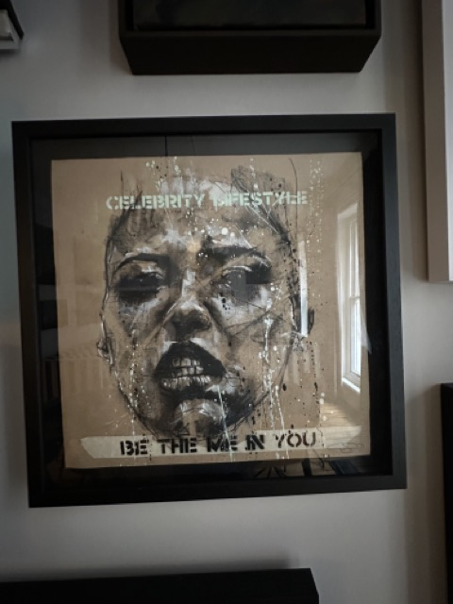
ARTIST: GUY DENNING
TITLE: BE THE ME IN YOU
SIZE: 50 X 50 CM ( FRAMED )
MEDIUM: MIXED MEDIA ON FINR ART PAPER
PRICE: £ 825.00

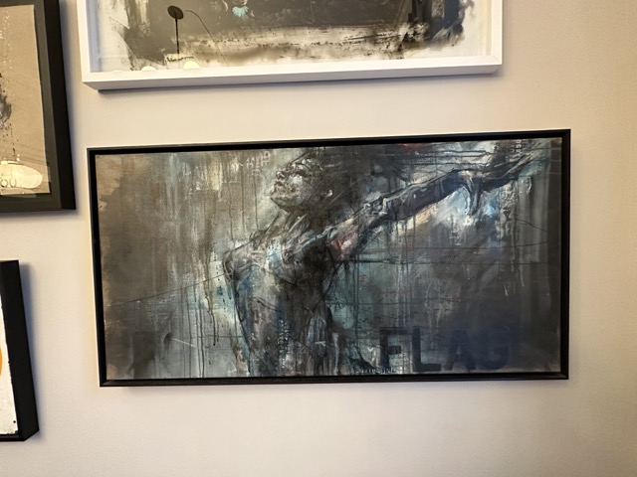
ARTIST: GUY DENNING
TITLE: FLAG
SIZE: 103 X 54 CM ( FRAMED )
MEDIUM: MIXED MEDIA ON FINE ART PAPER
PRICE: £ 3,300
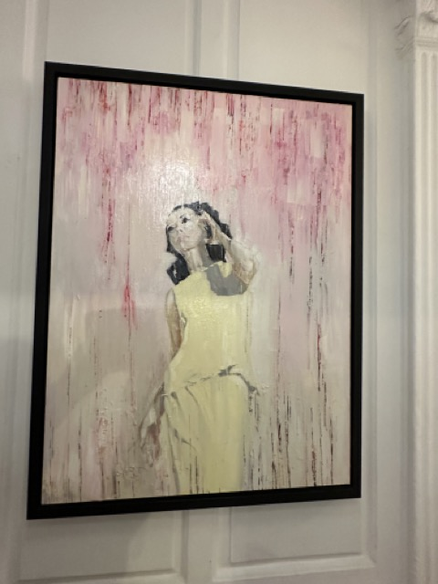
ARTIST: KIM TONG
TITLE: THE WISE & THE WHEREFORES
SIZE: 120CM X 100CM
MEDIUM: OIL ON LINEN TRAY FRAMED
PRICE: £ 4,400.00

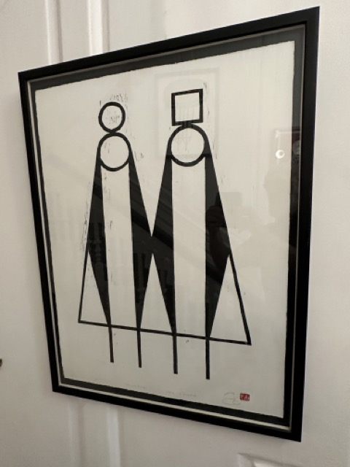
ARTIST: JOHN A PEDDER
TITLE: TWO OLD PUNKS
SIZE: 70 X 60 CM (FRAMED)
MEDIUM: WOOD BLOCK PRINT EDITION 100
PRICE: £ 295.00
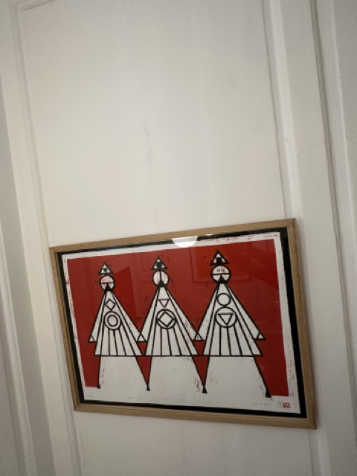
ARTIST: JOHN A PEDDER
TITLE: 3 SISTERS
SIZE: 70 X 60 CM (FRAMED)
MEDIUM: WOOD BLOCK PRINT EDITION 100
PRICE: £ 295.00
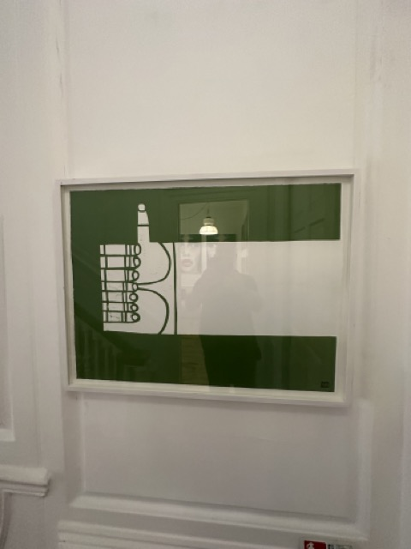
ARTIST: JOHN A PEDDER
TITLE: CONRAD (GREEN)
SIZE: 70 X 60 CM (FRAMED)
MEDIUM: WOOD BLOCK PRINT EDITION 100
PRICE: £ 395.00

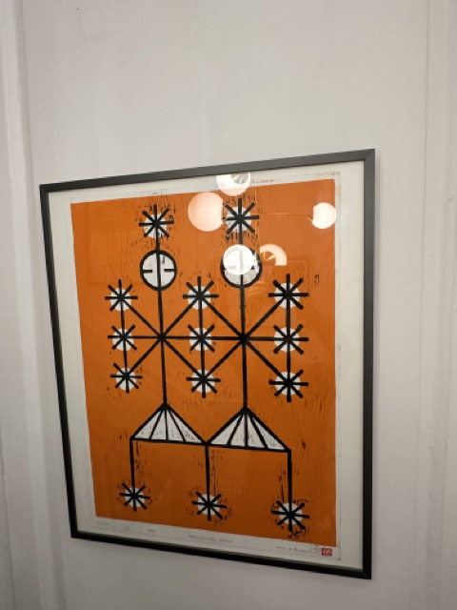
ARTIST: JOHN A PEDDER
TITLE: HAPPINESS ANGELS (ORANGE)
SIZE: 70 X 60 CM (FRAMED)
MEDIUM: WOOD BLOCK PRINT EDITION 100
PRICE: £ 295.00
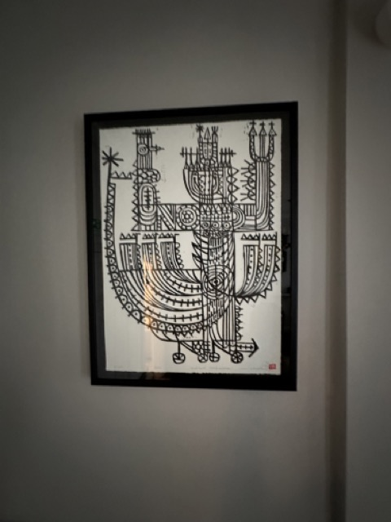
ARTIST: JOHN A PEDDER
TITLE: NEPTUNE IMPERSONATOR
SIZE: 70 X 60 CM (FRAMED)
MEDIUM: WOOD BLOCK PRINT EDITION 100
PRICE: £ 295.00

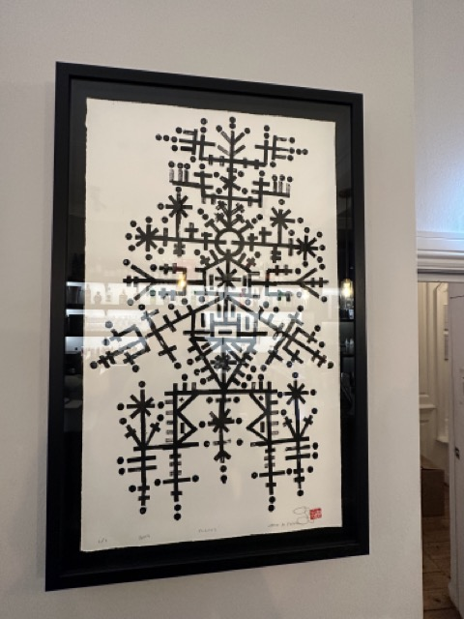
ARTIST: JOHN A PEDDER
TITLE: DIETY
SIZE: 70 X 90 CM (FRAMED)
MEDIUM: WOOD BLOCK PRINT (ORIGINAL 1/1)
PRICE: £ 475.00
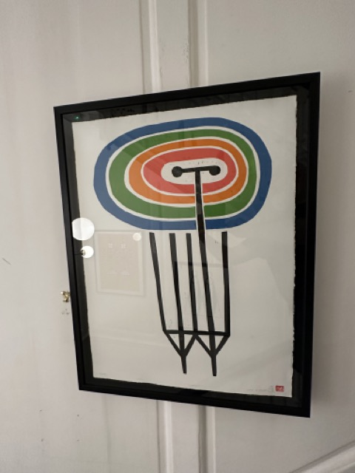
ARTIST: JOHN A PEDDER
TITLE: CLEMENT (MULTI COLOURED)
SIZE: 70 X 90 CM (FRAMED)
MEDIUM: WOOD BLOCK PRINT EDITION 100
PRICE: £ 295.00

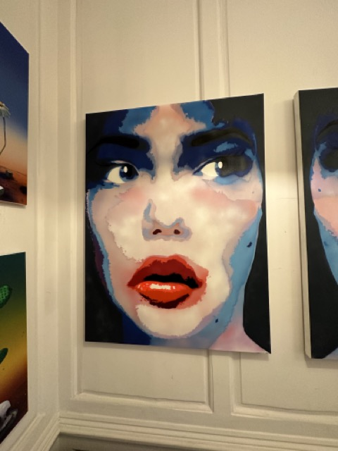
ARTIST: YVONNE WAYLING
TITLE: BE CAREFULOF THE COMPANY YOU KEEP (L)
SIZE: 120 X 90 CM
MEDIUM: SPRAY PAINT ON CANVAS
PRICE: £ 2,950.00
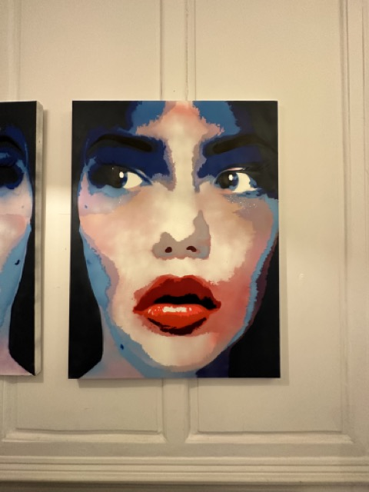
ARTIST: YVONNE WAYLING
TITLE: BE CAREFULOF THE COMPANY YOU KEEP (R)
SIZE: 120 X 90 CM
MEDIUM: SPRAY PAINT ON CANVAS
PRICE: £ 2,950.00
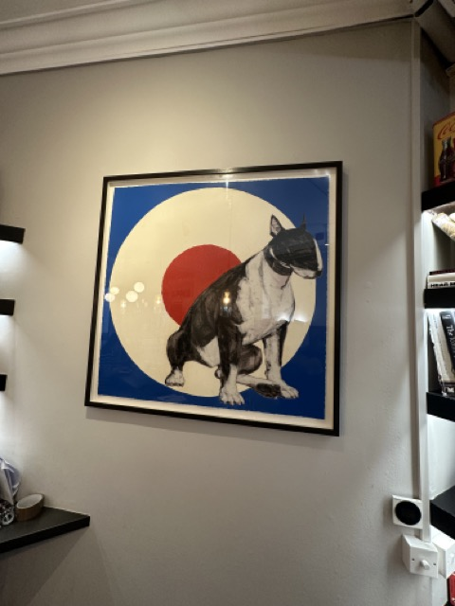
ARTIST: RAY RICHARDSON
TITLE: ONWARDS & UPWARDS
SIZE: 100 X 1000 CM
MEDIUM: SCREEN PRINT WITH WOOD BLOCK (EDITION 100
PRICE: £ 1,500.00

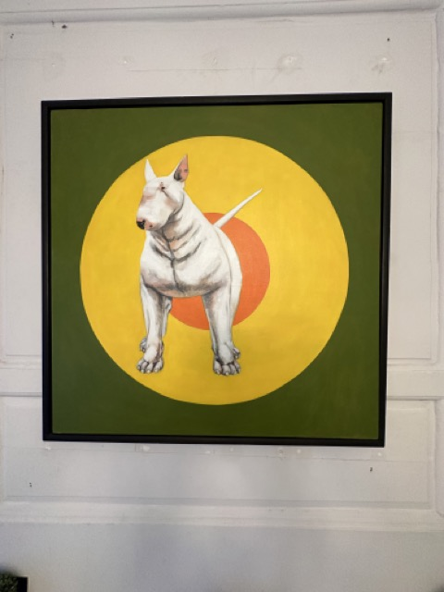
ARTIST: RAY RICHARDSON
TITLE: SOUL DEEP
SIZE: 107 X 107 CM
MEDIUM: OIL ON CANVAS ( TRAY FRAMED)
PRICE: £ 7,500.

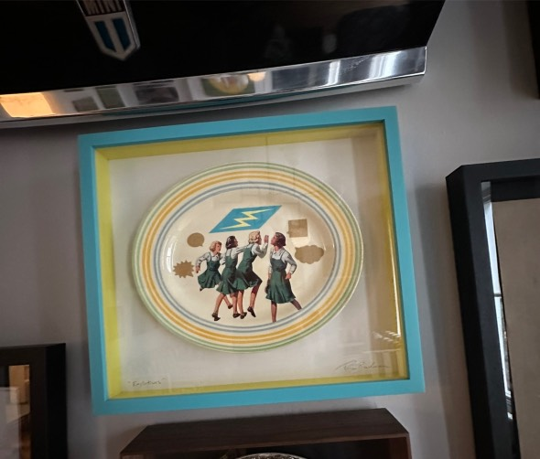
ARTIST: TOM BUCHANAN
TITLE: EXPLETIVES
SIZE: 120 X 90 CM
MEDIUM: MIXED MEDIA FRAMED
PRICE: £ 675.00

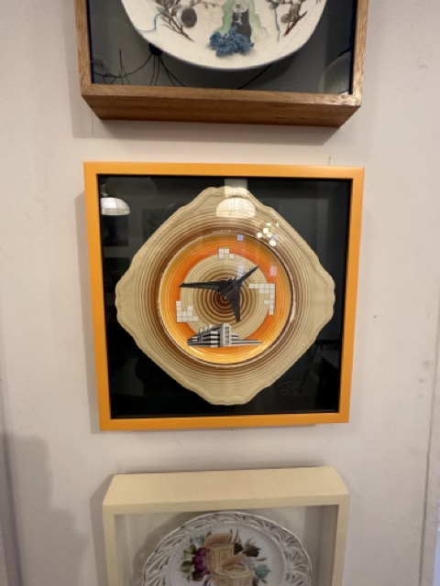
ARTIST: TOM BUCHANAN
TITLE: FUTURE CITIES VI
SIZE:
MEDIUM: MIXED MEDIA FRAMED
PRICE: £ 650.00

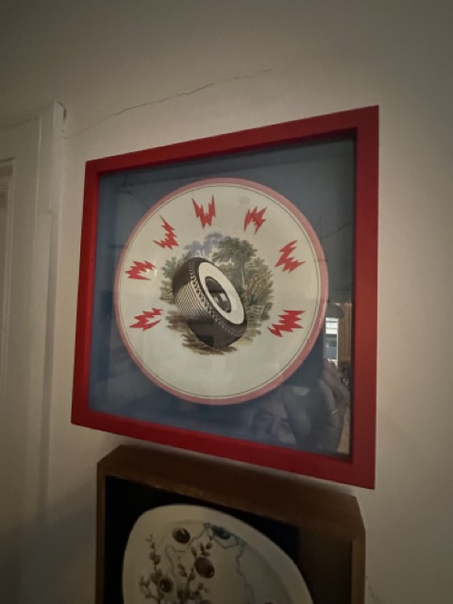
ARTIST: TOM BUCHANAN
TITLE: LE PNEU
SIZE:
MEDIUM: MIXED MEDIA FRAMED
PRICE: £ 725.00
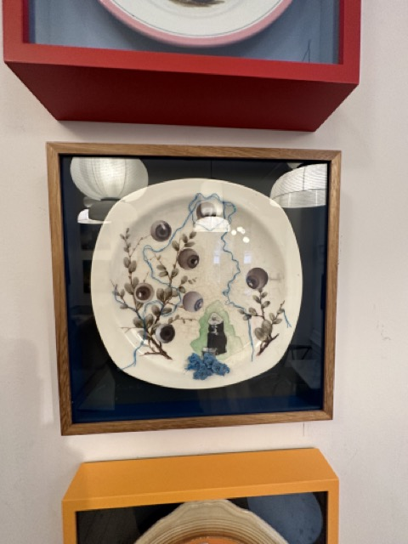
ARTIST: TOM BUCHANAN
TITLE: THE MOLE
SIZE:
MEDIUM: MIXED MEDIA FRAMED
PRICE: £ 675.00

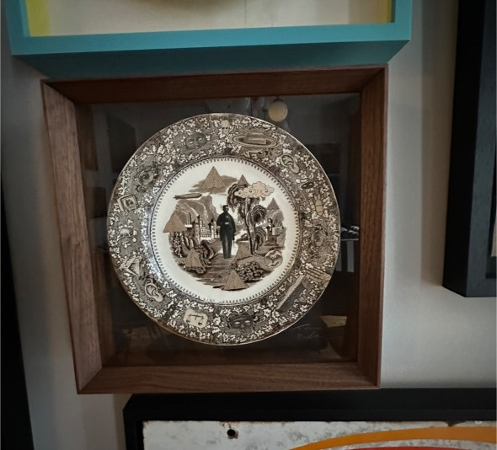
ARTIST: TOM BUCHANAN
TITLE: THE WATCH
SIZE:
MEDIUM: MIXED MEDIA FRAMED
PRICE: £ 625.00
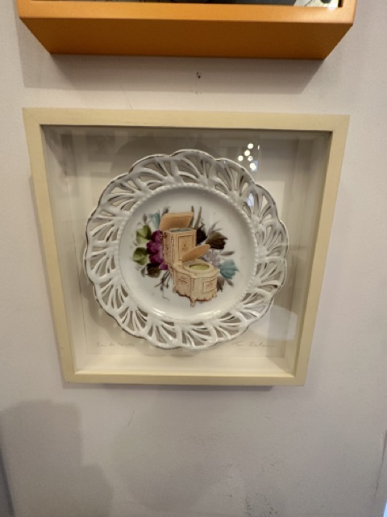
ARTIST: TOM BUCHANAN
TITLE: EAU DE TOILET
SIZE:
MEDIUM: MIXED MEDIA FRAMED
PRICE: £ 625.00

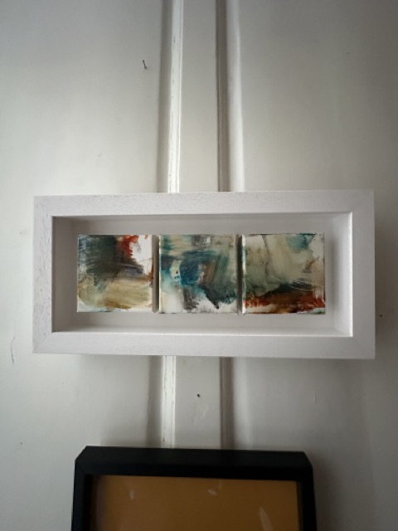
ARTIST: NIKKI HILL SMITH
TITLE: PALETTE PAINTINGS ( UNTITLED 1 )
SIZE: 52 x 25 CM. ( DEEP BOX FRAME )
MEDIUM: ACRYLIC ON CANVAS
PRICE: £ 600.00. (TRIPTYCH SET £1,600 )

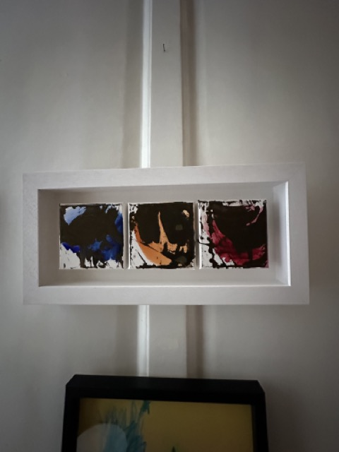
ARTIST: NIKKI HILL SMITH
TITLE: PALETTE PAINTINGS ( UNTITLED 2 )
SIZE: 52 x 25 CM. ( DEEP BOX FRAME )
MEDIUM: ACRYLIC ON CANVAS
PRICE: £ 600.00. (TRIPTYCH SET £1,600 )

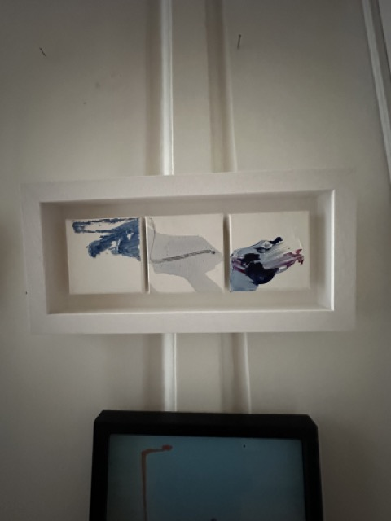
ARTIST: NIKKI HILL SMITH
TITLE: PALETTE PAINTINGS ( UNTITLED 3 )
SIZE: 52 x 25 CM. ( DEEP BOX FRAME )
MEDIUM: ACRYLIC ON CANVAS
PRICE: £ 600.00. (TRIPTYCH SET £1,600 )

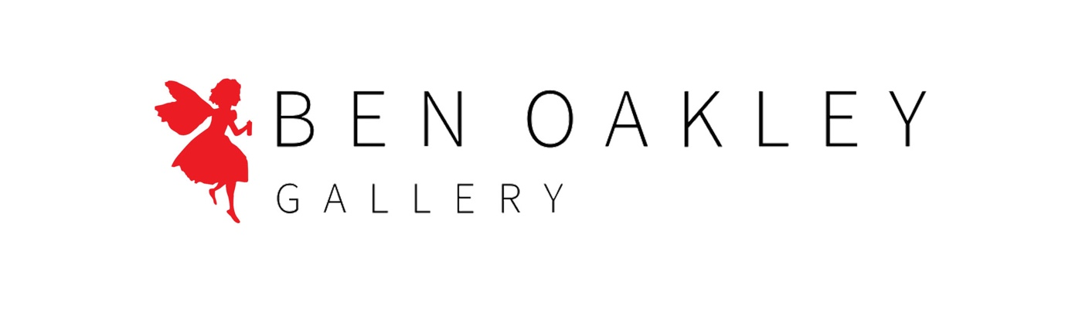
(Blue Peter) PDF ‘ MOJO RISING ‘ Oct 3rd 2024
All works subject to Copyright.

FOR COMMISSIONS, PLEASE CONTACT:
E: INFO@BENOAKLEYGALLERY.COM
T: 07976 692 751

BEN OAKLEY FRSA

